Factors affecting Solubility

Name

Date

Prelab Questions

- What is a solution? Are all mixtures solutions? Are all solutions mixtures?

A solution is a term that describes homogeneous or an even mixture of a solute in a solvent. Not all mixtures are solution, but all solutions are mixtures since its two or more substances being mixed together.

- Explain the terms solute and solvent.
A solute is a substance like salt or sugar that is being dissolved while the dissolving medium is called solvent. An example of solvent include water. The solute dissolves in solvent to form a solution.

- List all the factors that affect solubility.
Temperature
Polarity
Pressure
Molecular size
Surface area e.g. of a solid.

- Explain how the choice of a solvent can affect the solubility of a solute.
A strong solute- solvent attraction results to higher solubility whereas poor solute-solvent attraction lead to decreased solubility. Meanwhile, polar substances highly dissolves in polar solvents. Similarly, non-polar substances dissolves better in non-polar solvents.

Laboratory Report Results:
The laboratory data is in red.

- Nature of the solute and solvent.

- Solubility of iodine in ethyl alcohol: _Soluble________

Solubility of iodine in water: _Slightly Soluble_

- Volume of water needed to dissolve boric acid: _8.0 ml_________

Volume of water needed to dissolve sodium chloride: _8.0 ml___________

- Gross (mass of Erlenmeyer flask and sodium chloride residue)

- Mass of Copper (II) sulfate pentahydrate:

1st sample ___2.51 g______

2nd sample ___2.49 g_______

- Observations on dissolving Copper (II) sulfate pentahydrate:

Hot Water ___Dissolved completely______

Cold Water __Dissolved slightly_________
- Effect of a solute on boiling point.
- Mass of sodium chloride: 1st sample ___2.99 g______
2nd sample ___3.01 g_______
- Boiling points: Water ___103.0ºC______
Water + 1st sample ___104.0 ºC______
Water + 1st + 2nd sample ___105.0 ºC______

- Effect of solute on freezing point.

- Mass of sodium chloride: 1st sample ___1.01 g_____
2nd sample ____1.03 g_____
- Freezing points: Water ____3.0 ºC_____
Water + 1st sample ____1.0 ºC_____
Water + 1st + 2nd sample ____-1.0 ºC_____

Post lab Questions:

- Discuss the effect of increasing temperature on the dissolution of copper (II) sulfate pentahydrate in water.

The dissolution of copper (II) Sulfate pent hydrate in water will increase with increase in temperature. This is because the kinetic energy is increased. The water molecules are effectively break apart the of copper (II) Sulfate pent hydrate (solute), which are held together by inter-molecular forces.

- What effect does a solute have on the boiling point of a solvent? What effect does a solute have on the freezing point of a solvent?

A solute increases the boiling point of a solvent and it lowers the freezing point of a solvent.

- If 9.05 g of sodium chloride are soluble in 25.0 ml of water, calculate the amount of sodium chloride that will dissolve in 135 ml of water.

9.05g = 25.0ml
? = 135ml

= (9.05*135)/25)

=48.87g

- Would you expect the solubility of sodium chloride in water to increase or to decrease if the temperature is changed from 25 ºC to 80 ºC?

The solubility of sodium chloride will increase since the increase of temperature from 25 ºC to 80 ºC increases kinetic energy thus effectively breaking apart solutes.

CHEM 11111- Boyles Law and Gay-Lussac’s Law
Name: ___________________
- Boyle’s Law
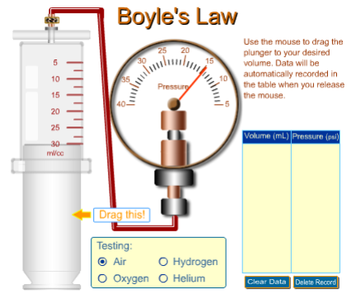
- Go to Simulation: https://pages.uoregon.edu/tgreenbo/boyles_law.html (credit: University of Oregon Foundation), [you need to unblock Adobe Flash on your browser for it to work, see last page]
- Select air (under testing)
- Drag the plunger up to change the volume
- Take 5 readings of volume of air in ml and pressure in lb/in², record in the table bellow
- Calculate inverse of volume (i.e. 1/volume)
Pressure of air (lb/in²) | Volume of air (ml) | Inverse of volume (1/ml)
0.972 | 10 | 0.1
1.88 | 5 | 0.2
1.27 | 7.5 | 0.133333
0.77 | 12.5 | 0.08
0.65 | 15 | 0.066667

- Using Excel, plot Pressure (in the y-axis) vs. Inverse of volume (in the x-axis)
- Insert the graph here:

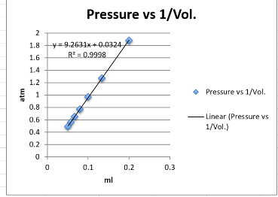

- Gay-Lussac’s Law
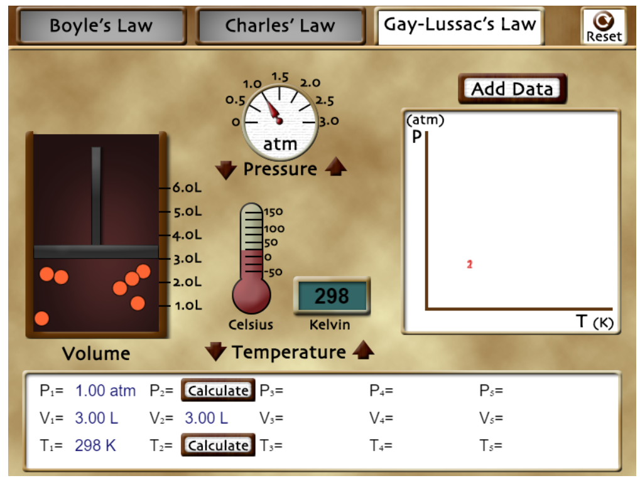
- Go to Simulation: https://teachchemistry.org/classroom-resources/the-gas-laws-simulation (credit: AACT), [you need to unblock Adobe Flash on your browser for it to work, see last page]
- Select Gay-Lussac’s Law button on the top
- Change the temperature in the simulation by clicking on the up/down brown arrows
- Take 5 readings of temperature in K and pressure in atm, record in the table bellow
- Calculate temperature in ⁰C
Pressure of air (atm) | Temperature of air (ºC) | Temperature of air (K)
36.0 | -150 | 173
46.4 | -100 | 223
56.7 | -50 | 273
67.1 | 0 | 323
77.7 | 50 | 373

- Using Excel, plot Pressure (in the y-axis) vs. temperature in K (in the x-axis)
- Insert the graph here:
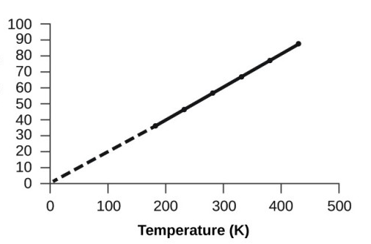

Determining the Molarity Name ___________________
and Percent Mass/Volume Date ___________________
of Sodium Chloride Solution

Prelab Questions

1. What is the molarity of sodium chloride solution prepared by dissolving 10.0 grams in 100.0 mL of solution?

Molarity= moles of solute/volume of solution in liters
Molar Mass of NaCl= 23+ 35.5
=58.5
Given mass of solute is= 10g
Moles= mass/molar mass
Moles of NaCl= 10/58.8
=0.17006 m

Volume of solution is 100Ml= 0.1
Molarity of solution= 0.17006/0.1
=1.7M

- What is the percent mass/volume of sodium chloride solution made by dissolving 5.0 grams of sodium chloride in 40.0 mL of solution?
Percentage mass/volume= (5g*100%) /40ml
= 12.5 %( m/v)
3. What is the percent mass/volume and molarity of sodium chloride solution, if 2.0 grams of salt is collected by evaporating from 30.0 mL of sodium chloride solution?

Percentage mass/volume= (2g*100%)/30ml
= 6.67% (m/v)

Laboratory Report Results:
The laboratory data is in red.

- Volume of sodium carbonate solution (unknown concentration) __20 mL____
- Gross (mass of Erlenmeyer flask and sodium chloride residue) __132.82 g__
- Tare (mass of Erlenmeyer flask) __130.36 g__
- Net (mass of sodium chloride) __2.48 g____

Post lab Questions:

5. Using the data in the laboratory report results:
a. Calculate the molarity of sodium chloride solution.
Molar mass= 58.44g/mol
Mass of solute= 2.48g
Moles of Sodium chloride= mass/molar mass
=2.48/58.44
= 0.04243moles
Volume of solution=20ml=0.02
= (0.04243)/0.02
= 2.1M
b. Calculate the percent concentration (% w/v) of sodium chloride.
To calculate w/v%= (mass of solute/Volume of solution in ML) *100%
= (2.48g/20ml)*100
=12.4%
- If you evaporated 40.0 mL instead of 20.0 mL of sodium chloride solution, how many grams of sodium chloride could you expect to collect?

20Ml= 2.48g

40ml=?

(40*2.28)/20
= 4.96g

CHEM homework 2

2.6 Convert the following numbers to scientific notation:
a. 26487 = 2.6487 x 10⁴ b. 0.00083= 8.3 x 10⁻⁴
c. 5032.064 = 5.032064 x 10³ d. 0.0421= 4.21 x 10⁻³

2.8 What are the full names of the following units?
a. mg= milligram b. mL= Milliliter c. cm = centimeter

d. pg= pictogram e. µg= Micrograms f. nm = nanometer

2.10 How many micrograms are in 1 g?
= 1000000mg

2.12 How many grams are in 1 kg?
=1000g

2.14 Carry out the following conversions:
a. 0.034 kg to g __=34g b. 0.25 L to mL ___250ml
c. 2.54 x 10⁻³L to mL= 2.54ml d. 123 µg to g= 0.000123g
e. 12345 pg to g=1.2345e-8 f. 5.17 x 10⁴mL to L = 5170l
g. 9.27 x 10⁻²g to mg=92.7mg h. 7.26 x 10⁵ cm to m =7260
i. 4.86 x 10⁶m to km= 4860km j. 1.54 x 10⁻¹⁰m to pm= 0.01pm
k. 1.83 x 10⁻⁸m to nm= 0.1nm l. 0.0015 m to cm =0.15
m. 3254 mm to m = 3.254m n. 658 mg to g =0.658g

2.16 Carry out the following conversions:
a. 3.45 x 10⁴ cm³ to m³= 0.0345m³ b. 7.25 x 10³ mm³ to cm³= 7.25cm³

c. 2.85 x 10⁵ m³ to km³ = 0.000285km³ d. 0.05 L to cc= 50cc

e. 0.25 L to mL = 250Ml f. 200 cc to L= 0.2L

g. 2 x 10³ µL to cc =0.2

2.18 Use the conversion factors below to determine the number of feet in 1 mile.
1 km = 0.6214 mile= 3280.992
1 ft = 12 inches =12
1 in = 2.54 cm =1.57828e-5

2.20 Carry out the following conversions:
a. 1.02 g/cm³ to kg/L= 1.02 b. 65 mile/hr. to km/hr= 104.607

2.22 An IV solution contains 50.0 g glucose per 1000.0 mL of the solution. If a patient is supposed to receive 20 g of glucose, how many milliliters of the solution should be given to the patient? Hint: Use the concentration of the solution (50.0 g glucose/1000.0 mL of the solution) as a conversion factor and the 20 g of glucose as the given to solve this problem.
50.0 g = 1000 ml
20.0 g = ?
20. g x 1000 ml / 50.0 g = 400.0 mL

2.24 In human blood, the average concentration of glucose is about 80 mg per 100 mL of blood. If an average human body contains about 8 liters of blood, how many grams of glucose are in the blood? One pound is equal to 454 g. How many pounds of glucose are in the blood?
=80mg =100ml
?= 8000ml
=6400mg/1000= 64g
64 x 454= 29056pounds
2.26 Element osmium, Os, is the densest mental whose density is 22.57 g/cm³. What is the mass, in grams, of a block of osmium that measures 1.00 cm x 2.00 cm x 3.00 cm?
Mass= Density X volume
22.57 g/cm³ x 6cm³ = 135.42g
2.28 A person jogging consumes 7.0 kcal of energy per minute. How many minutes of such exercise would be required to burn 500 kcal, the energy in a Big Mac.?
7.0 kcal= I min
500kcal=?
500/7= 71.43mins

